Angular 21 Web Components Integration
Integrating Web Components (Custom Elements) into Angular 21 is straightforward.

Because modern Angular relies fully on a standalone architecture rather than traditional modules (NgModule), the configuration process is cleaner and can be applied directly to individual standalone components or globally via the application configuration. [1, 2]

Here is a step-by-step exercise on how to integrate and use third-party Web Components in an Angular 21 application.
- Prepare a new WebComponentIntegration application.
- Install the Web Component Library
First, add your desired Web Component library to your project dependencies using npm or yarn. For this example, we will use a generic or popular library like @shoelace-style/shoelace or any custom UI package:

npm install @shoelace-style/shoelace

- Include the Theme & Assets
Angular needs to load the Shoelace stylesheets and copy its static assets (like icons) to your public distribution folder. [1]

Update your angular.json file under projects -> [your-app] -> architect -> build -> options:
angular.json
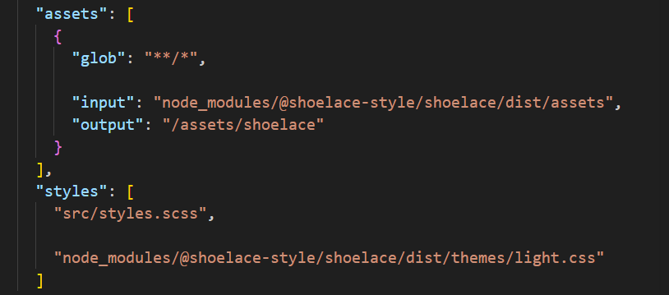

- Define or Import the Custom Elements
The browser needs to register the Web Components before they can render. You must import the registration files so that customElements.define() is triggered globally. [1, 2]. You can do this at the application entry point, main.ts: [1]
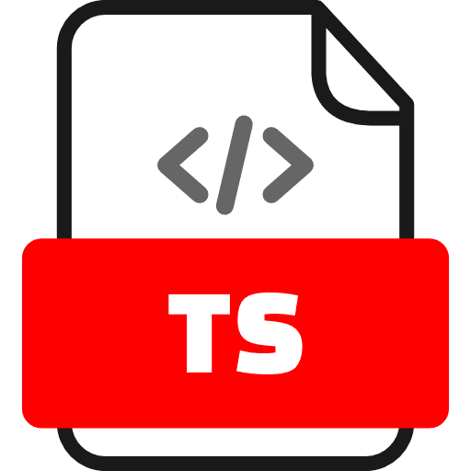
import { bootstrapApplication } from '@angular/platform-browser';
import { appConfig } from './app/app.config';
import { App } from './app/app';

// Import Shoelace utilities and register components
import '@shoelace-style/shoelace/dist/components/button/button.js';
import '@shoelace-style/shoelace/dist/components/rating/rating.js';
// Add other specific component imports as needed

// Set base path pointing to your assets directory configuration
import { setBasePath } from '@shoelace-style/shoelace/dist/utilities/base-path.js';
setBasePath('/assets/shoelace');

bootstrapApplication(App, appConfig)
.catch((err) => console.error(err));

- Enable CUSTOM_ELEMENTS_SCHEMA
By default, the Angular compiler will throw an error if it encounters an HTML tag it does not recognize (i.e., anything that isn't a native HTML element or a declared Angular component). To allow the template to accept Web Components, you must add the CUSTOM_ELEMENTS_SCHEMA. [1, 2, 3]

In Angular 21's standalone design, you do this directly in the @Component decorator metadata of the component where you plan to use the element:
ng g c DashboardComponent
import { Component, CUSTOM_ELEMENTS_SCHEMA } from '@angular/core';

@Component({
selector: 'app-dashboard',
standalone: true,
imports: [],
// Add the schema here
schemas: [CUSTOM_ELEMENTS_SCHEMA],
templateUrl: './dashboard-component.html',
styleUrl: './dashboard-component.scss'
})
export class DashboardComponent {
// Logic goes here
}
Note: If you want to enable Web Components globally across your entire app without adding the schema to every file, you can instead include it inside your global configuration file (app.config.ts) under the compiler options.

- Use Web Components in Templates
Now you can seamlessly use the custom elements inside your template file (dashboard-component.html). Angular data binding syntax ([] for inputs/properties and () for outputs/events) works natively with custom elements. [1]
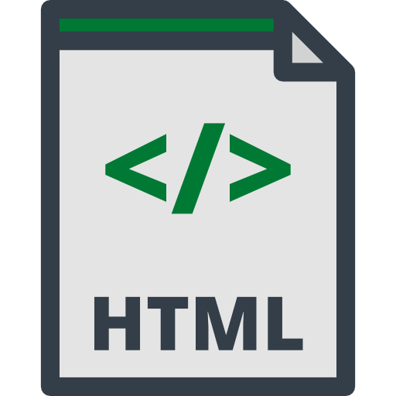
<!-- Native Angular properties bound directly to Web Component attributes -->
<sl-button variant="primary" (click)="onButtonClick()">
Click Me
</sl-button>

<!-- Property binding and Event listening work naturally -->
<sl-rating
[value]="currentRating()"
(sl-change)="onRatingChange($event)">
</sl-rating>

- Handling Events in dashboard-component.ts.
When handling events emitted by third-party Web Components.

import { Component, CUSTOM_ELEMENTS_SCHEMA, signal } from '@angular/core';

@Component({
selector: 'app-dashboard',
standalone: true,
schemas: [CUSTOM_ELEMENTS_SCHEMA],
templateUrl: './dashboard-component.html'
})
export class DashboardComponent {
// Using Angular Signals for reactivity
currentRating = signal(4);

onButtonClick(): void {
alert('Current rating is ' + this.currentRating());
}

onRatingChange(event: any): void {
this.currentRating.set(event.target.value);
}
}

- Route to the Dashboard Component
app.ts
import { Component, signal } from '@angular/core';
import { RouterOutlet } from '@angular/router';
import { DashboardComponent } from './dashboard-component/dashboard-component';

@Component({
imports: [RouterOutlet, DashboardComponent],
selector: 'app-root',
styleUrl: './app.scss',
templateUrl: './app.html',
})
export class App {
App(){
console.log('Calling App')
}
protected readonly title = signal('WebComponentIntegration');
}

app.html
<app-dashboard/>
<router-outlet/>
- Save all files and test run
ng serve --open
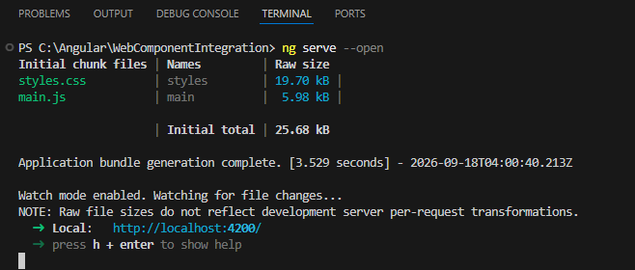

Browser
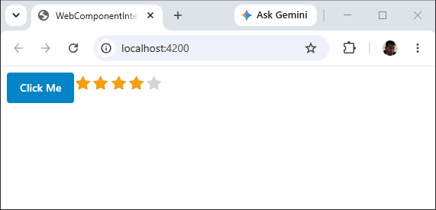
Try click the stars then click the button
- Shutdown the application

Alternative: Exporting an Angular Component as a Web Component
If instead of consuming a web component you want to turn an Angular 21 component into a reusable Web Component for other frameworks, you should leverage the @angular/elements package: [1, 2]
- Install elements: npm install @angular/elements
- Define the custom element behavior using createCustomElement in your application initializer function or inside main.ts. [1, 2, 3]

